 | National University  of Computer and Emerging Sciences  Chiniot-Faisalabad Campus  Department of Artificial Intelligence and Data Science | 
Course Code | AI4002
Course Title | Computer Vision – Lab
Lab Task | 8
Due Date (A Section) | 09:00 pm - 14 October 2025
Due Date (B Section) | 09:00 pm - 17 October 2025
Instructions:
- Rename this Word file as LT8_22F-3170
- If found plagiarism, straight zero will be marked against task.
- Submit task on Due Date. No Late Submission will be Tolerated.

Question 1
The SIFT algorithm extracts feature descriptors around interest points in an image to uniquely describe their local texture patterns. Consider a single grayscale image and a single interest point located at coordinates (x, y). You are required to extract a 128- dimensional SIFT feature descriptor around this interest point.

Write Python code for extracting a 128-dimensional descriptor around one interest
point using the following assumptions:
- Image gradients Gx and Gy are already computed.
- Feature point = (x, y).
- Window size = 16×16.
- Sub-block size = 4×4.
- Orientation bins = 8.
Write a Python function that performs descriptor extraction as described above:
import numpy as np
def compute_descriptor(Gx, Gy, x, y):
# Your code here
return descriptor # shape (128,)
The function should:
1. Take gradient matrices Gx, Gy and interest point (x, y).
2. For each 4×4 block in the 16×16 window:
o Compute gradient magnitude and orientation.
o Build an 8-bin histogram.
3. Concatenate all 16 histograms to form the 128-dimensional vector.
Code
import cv2
import numpy as np
import matplotlib.pyplot as plt

def compute_descriptor(Gx, Gy, x, y):
window_size = 16
block_size = 4
num_bins = 8
half = window_size // 2

# Extract 16x16 window centered at (x, y)
window_Gx = Gx[y - half:y + half, x - half:x + half]
window_Gy = Gy[y - half:y + half, x - half:x + half]

descriptor = []

# Divide into 4x4 blocks
for i in range(0, window_size, block_size):
for j in range(0, window_size, block_size):
block_Gx = window_Gx[i:i + block_size, j:j + block_size]
block_Gy = window_Gy[i:i + block_size, j:j + block_size]

# Compute magnitude and orientation
magnitude = np.sqrt(block_Gx**2 + block_Gy**2)
orientation = np.degrees(np.arctan2(block_Gy, block_Gx)) % 360

# Create 8-bin histogram
hist = np.zeros(num_bins)
for m in range(block_size):
for n in range(block_size):
bin_index = int(orientation[m, n] // 45) % num_bins
hist[bin_index] += magnitude[m, n]

# Normalize histogram
norm = np.linalg.norm(hist)
if norm != 0:
hist = hist / norm

descriptor.extend(hist)

# Convert to numpy array and normalize entire descriptor
descriptor = np.array(descriptor)
descriptor = descriptor / np.linalg.norm(descriptor)

return descriptor # shape (128,)

# -------------------------------
img = cv2.imread(r'lab.png', cv2.IMREAD_GRAYSCALE)

img = np.float32(img)

# Compute gradients using Sobel operator
Gx = cv2.Sobel(img, cv2.CV_32F, 1, 0, ksize=3)
Gy = cv2.Sobel(img, cv2.CV_32F, 0, 1, ksize=3)

# -------------------------------
# Step 3: Select an Interest Point
# -------------------------------
# Use the center pixel as the interest point
y, x = img.shape[0] // 2, img.shape[1] // 2

# -------------------------------
# Step 4: Compute Descriptor
# -------------------------------
descriptor = compute_descriptor(Gx, Gy, x, y)

# -------------------------------
# Step 5: Display Results
# -------------------------------
print("Descriptor shape:", descriptor.shape)
print("First 10 values of descriptor:\n", descriptor[:10])

# Show the original image with the interest point marked
plt.figure(figsize=(6, 6))
plt.imshow(img, cmap='gray')
plt.scatter(x, y, c='red', s=40, marker='x', label='Interest Point')
plt.title("Original Image with Interest Point")
plt.legend()
plt.axis('off')
plt.show()

# Show the 16x16 patch around the interest point
half = 8
patch = img[y - half:y + half, x - half:x + half]

plt.figure(figsize=(3, 3))
plt.imshow(patch, cmap='gray')
plt.title("16x16 Window around Interest Point")
plt.axis('off')
plt.show()

Screenshot
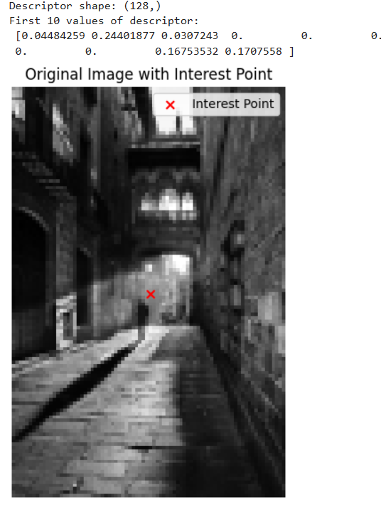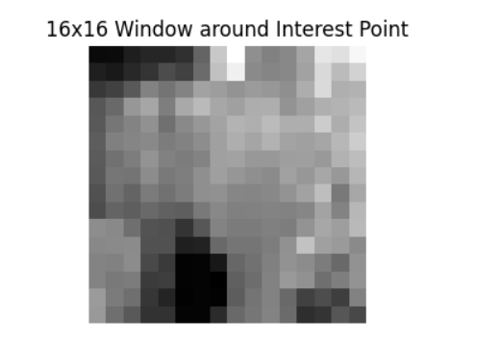

Question 2
The Histogram of Oriented Gradients (HOG) is a feature descriptor used to capture local shape information from an image by analyzing the distribution of intensity gradients or edge directions. You are required to develop and explain the process of extracting a HOG feature descriptor from a grayscale image for one detection window.

Write a Python program (without using built-in HOG functions) to:
1. Convert a grayscale image into gradients using Sobel operators.
2. Compute the gradient magnitude and orientation for each pixel.
3. Divide the image into 8×8 pixel cells.
4. For each cell, build a histogram of gradient orientations (0°–180°) with 9 bins.
5. Group 2×2 cells into a block and normalize the histogram values.
6. Concatenate all normalized histograms into one HOG feature vector.
You may test your code on a simple 128×128 pixel grayscale image.
Code
import cv2
import numpy as np
import matplotlib.pyplot as plt

def compute_HOG(img):
# 1. Compute gradients using Sobel operator
gx = cv2.Sobel(img, cv2.CV_32F, 1, 0, ksize=3)
gy = cv2.Sobel(img, cv2.CV_32F, 0, 1, ksize=3)

# 2. Compute gradient magnitude and orientation (0°–180°)
magnitude = np.sqrt(gx**2 + gy**2)
orientation = np.degrees(np.arctan2(gy, gx)) % 180

cell_size = 8 # 8x8 pixel cells
bin_size = 9 # 9 orientation bins
angle_unit = 180 / bin_size

h, w = img.shape
cell_h = h // cell_size
cell_w = w // cell_size

# 3. Initialize HOG feature array
histograms = np.zeros((cell_h, cell_w, bin_size))

# 4. Compute histogram for each cell
for i in range(cell_h):
for j in range(cell_w):
cell_mag = magnitude[i*cell_size:(i+1)*cell_size,
j*cell_size:(j+1)*cell_size]
cell_ori = orientation[i*cell_size:(i+1)*cell_size,
j*cell_size:(j+1)*cell_size]

# Create histogram for the current cell
hist = np.zeros(bin_size)
for y in range(cell_size):
for x in range(cell_size):
bin_idx = int(cell_ori[y, x] // angle_unit) % bin_size
hist[bin_idx] += cell_mag[y, x]
histograms[i, j] = hist

# 5. Normalize across 2x2 cell blocks
block_size = 2
block_features = []
for i in range(cell_h - 1):
for j in range(cell_w - 1):
block = histograms[i:i+block_size, j:j+block_size, :].ravel()
norm = np.sqrt(np.sum(block**2) + 1e-6)
block = block / norm
block_features.append(block)

# 6. Concatenate all block features
hog_vector = np.concatenate(block_features)

return magnitude, orientation, hog_vector

img = cv2.imread(r'lab.png', cv2.IMREAD_GRAYSCALE)
if img is None:
print("Image not found!")
exit()

magnitude, orientation, hog_vector = compute_HOG(img)

print("HOG Descriptor Shape:", hog_vector.shape)
print("First 10 values:", hog_vector[:10])

plt.figure(figsize=(12, 4))
plt.subplot(1, 3, 1)
plt.title("Original Image")
plt.imshow(img, cmap='gray')

plt.subplot(1, 3, 2)
plt.title("Gradient Magnitude")
plt.imshow(magnitude, cmap='gray')

plt.subplot(1, 3, 3)
plt.title("Gradient Orientation")
plt.imshow(orientation, cmap='hsv')

plt.show()

Screenshot
